What is Cyber Security ?

--> It is a technique of protecting your devices and network from external/internal threats and damages.

How you are going to provide security

---> Log : Its is a file that consists of information related to activity/ events performed by user / device.

Whom we are going to provide Security

--- > Each and every employee / device that belongs will be required to provide security, An additional layer of security will be added to
higher level executive.

-----------------------------------------------------------------------------------------------------------------------------------

Roles and responsibilities:

Security Analyst(SOC Team - Security Operations center)

Level -L1 Level Analyst

-->Monitor for security Incidents 24/7, analyse them and investigate if any True positive
incidents on your network . Using SIEM Tools, Performing threat hunting based on logs available and performing remediation/Mitigation steps as per
the Escalation matrix.
-->Generating /Preparing reports on various log sources and sharing it to management.
-->Identifying for latest vulnerability and threat advisories from threat Intel sources.
-->Spam/ Phishing email Analysis.
-->Identifying vulnerable devices in your network and initiating patch cycle.

L2 Level Analyst :

--- Perform threat hunting/ Malware analysis and create new alarms to identify security incidents in the network
--- Supporting and validating L1 tasks, Fine-tuning alarms to reduce false positive incidents on our network.
--- Security applications Health check up etc, Reports to management.

l3 Level Analyst / Admin :

--- Suggest Use-cases(Rules, Reports or dashboards) and devices to identify security incidents on our network
--- Troubleshooting Log Sources -- Maintaining tools, Recommending new tools to identify security Incidents
--- Understanding clients requirement and getting tasks done from L1 and L2 level engineers

SOC Managers :

-- Managing peoples tasks and creating policies and protocols for hiring, and building new processes

CISO : Chief Information Security Officer:
-- They are the final word on strategy, policies, and procedures involved in all aspects of cyber security

------------------------------------------------------------------------------------------------------------------------
Different types of teams with in the Organization
NOC Team / Network Team : they are work on network related incidents.
Windows team / help-desk
Endpoint / Antivirus team
Server management team
Application management team.

Different vectors in Security
Security Engineers

VAPT Engineers

SECOPS

Network
------------------------------------------------------------------------------------------------------------------------------
Security Tools and their Functionalities
SIEM (Security information and event management tool):

HP ArcSight
McAfee Nitro
IBM QRadar
Google chronicles
Exabean
DNIF
Securonix
Wazuh
Splunk

Collecting Logs for multiple log sources in out infrastructure :
Creating Security Use cases based on the management requirements :
Identifying Security Incidents based on the use-cases designed :
Analyzing incidents by centralize logs from different log sources :
Responding to an event / incident based on the SLA(Service level agreements) designed and Escalation matrix provided - Expedite Incident response.

Alarms - Classification
True Positive -- Alarm that has been triggered and identified to be a threat upon investigation -- Mitigation and Remediation
False Positive -- Alarm triggered but no threat associated upon the investigation -- Fine-tune use cases
True Negative --- No Alarm associated with the threat , Which we have to identify security incidents performing threat hunting and malware analysis -- Which we are going to develop new use-cases to trigger as an alarm

-------------------------------------------------------------------------------------------------------------------------

Event -- Action performed by the user - Log generated
Incident -- Which is an event turned out to be threat
Alarm -- Action that has been matched with the security condition provided

SOC -- Security Operations -- Its a place where logs will be centralized to Monitoring, Identify and investigate security incidents on the infrastructure

GSOC --- Global Security Operations

SSOC --- Shared Security Operations Center.

Networking

IP : Internet Protocal address is a numerical number which helps us in establishing communication between devices with in the network
--Ip address are unique with in the network
-- Ip address are utilized to communicate with in the network

IPs are classified into

Foe every communication there will be Source IP and a Destination IP

private IPs : IP address existing with in our network, non routable.

Class A : 10.0.0.0 -- 10.255.255.255 -- 256*256*256 = 16777216
Class B : 172.16.0.0 -- 172.31.255.255 -- 256*256*16 = 1048576
Class C : 192.168.0.0 -- 192.168.255.255 -- 256*256 = 65536

Public IPs : Ip address existing over the internet, Routable.

Communication :

Source Ip : private --- Destination : public --- Outbound communication
Source Ip : Public --- Destination : private --- Inbound communication
Source Ip : Private --> Destination : Private --- Internal communication
Source IP : Public --- > Destination : Public --- External communication

How to identify my private Ip ?

Windows + R --- > cmd ---> IPConfig

How to identify my public ip ?

Browser --> what is my Ip

How to identify your hostname ?

Windows + R --- > cmd --->Hostname

Differences between private IPs and Public IPs

- Private IPs are free of cost allocated your admin team
- Public Ips are paid
- Private Ips are Non Routable , Public IPs are Routable
- Private Ips are Unique with in private Network , Public Ips are Unique with in the internet
- Private Ips utilised in internal communication , Public Ips utilized in communication over internet

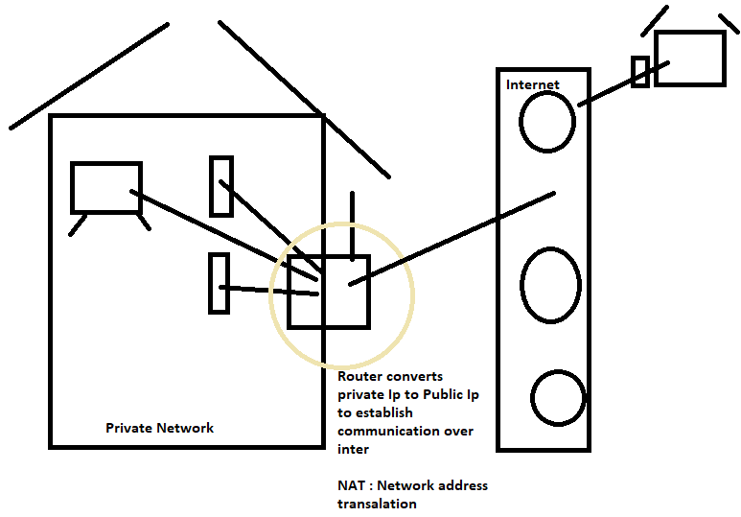Router- Provides a Public IP to devices in our network to communicate over the Internet- It translated private IP to Public Ip which we will be called as Network address translation(NAT).

