

Penetration Testing Report

Date: [Date]
Version: 0.1

By | For
zSecurity  9 Robinhood Road,  Dublin,  Ireland  Email: info@zsecurity.org  Phone: 011234567 | [Company Name]  ID#11111
Pentester 1 - pentester1@zsecuritu.org  Pentester 2 - pentester2@zsecurity.org | John Doe (CTO) - john@companyname.com  Jane Doe (IT Manager) - jane@company.com

Page 1 - Confidential www.zSecurity.com

Table of Contents
Executive Summary ............................................................................................................................... 3
1 Engagement Summary.......................................................................................................... 4 1.1 Scope.......................................................................................................................................... 4
1.2 Risk Ratings................................................................................................................................. 4
1.3 Findings Overview....................................................................................................................... 5
2 Technical Details.................................................................................................................. 6 2.1 SQL Injection ……………………………………….......................................................................... 6 2.2 Cross-site Request Forgery ………………………………………….............................................. 7 2.3 Information Disclosure ........................................................................................................................ 8

Page 2 Confidential www.zSecurity.com

Legal
Confidentiality
This document contains sensitive and confidential information, it should not be shared with any other 3rd parties without written permission.
GDPR
Disclaimers
…..etc

Change Log

Date | Version | Comments
1/1/2021 | 0.1 | Initial Report
10/1/2021 | 0.2 | Recon Stage

Page 3 Confidential www.zSecurity.com

Executive Summary
[CompanyName] engaged zSecurity to conduct a security assessment and penetration testing against a [website / app / web application]. The main goal of the engagement was to evaluate the security of the platform and identify possible threats and vulnerabilities.
This report details the scope of the engagement, detailed information about all of the findings and some recommendations. The summary below is intended for non-technical audiences to give an idea of the overall results of the engagement and the key findings. The second section of this report is intended for a technical audience as it lists all of our findings in detail, along with reproduction steps, analysis and recommendations.
Based on the security assessment we carried for [platform] and based on our findings, the current risk rating is high . The vulnerabilities discovered can be used by malicious actors to cause breaches and even gain unauthorised access to some management pages. The methodology followed is detailed in the following diagram:
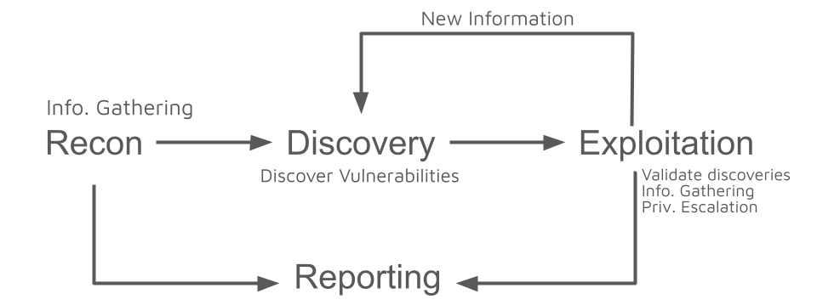

The following charts summarize the findings grouped by severity of the threat:
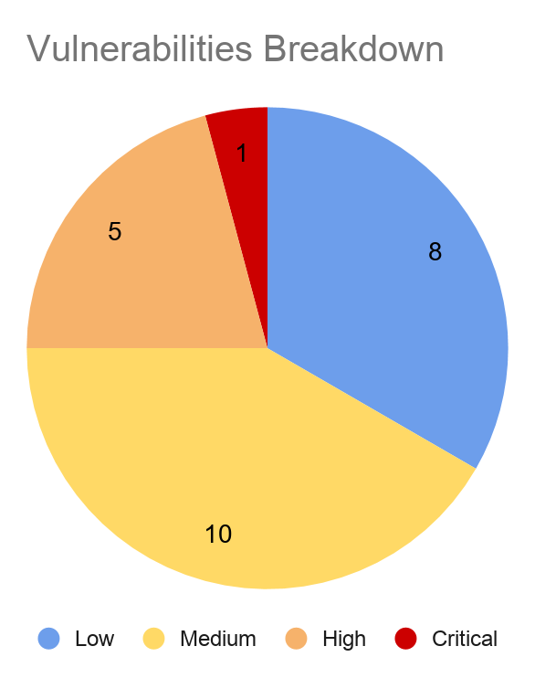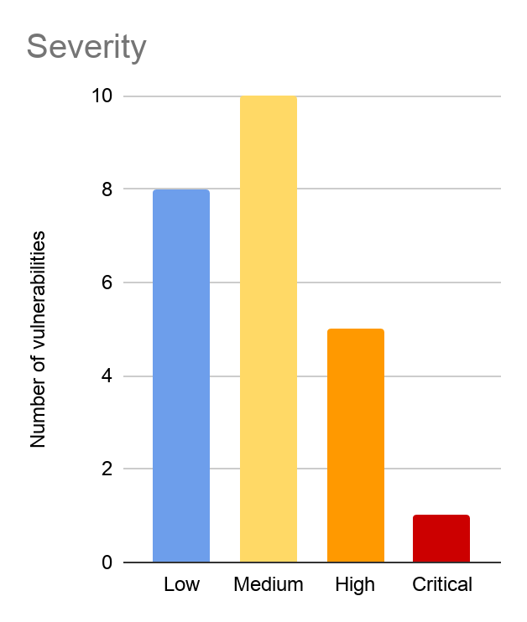

Page 4 Confidential www.zSecurity.com

1 Engagement Summary
1.1 Scope
As requested the security assessment was only carried out on the following targets:
IP
Domain.com
Subdomain.domain.com
Subdomain2.domain.com
…...etc

1.2 Risk Ratings
The vulnerability risk was calculated based on the Common Vulnerability Scoring System (CVSS v3.0) which is the industry standard for assessing the severity of security vulnerabilities.
The table below gives a key to the risk naming and colours used throughout this report to provide a clear and concise risk scoring system.

Risk | CVSS v3.0 Score | Recommendation
None | 0.0 | N/A
Low | 0.1 - 3.9 | Fix at the next update cycle.
Medium | 4.0 - 6.9 | Fix immediately if there are 0 medium risk vulnerabilities.
High | 7.0 - 8.9 | Fix immediately if there are 0 critical vulnerabilities.
Critical | 9.0 - 10.0 | Fix immediately.

Page 5 Confidential www.zSecurity.com

1.3 Findings Overview
Below is a list of all the issues found during the engagement along with a brief description, its impact and the risk rating associated with it. Please refer to the “Risk Ratings” section for more information on how this is calculated.

ID | Risk | Description
1 | Critical | SQL Injection leading to unauthorised database access.
2 | Medium | CSRF -Clients can be forced to submit certain non-critical requests.
3 | Low | PHP version disclosure - Can help develop attacks for this specific version.

Page 6 Confidential www.zSecurity.com

2 Technical Details
2.1 SQL Injection CRITICAL ID: 1
We discovered that using specially crafted requests a malicious actor can communicate with the database and query it to retrieve stored data including data stored in the users tables.

URL | https://domain.com/news/post.php
Parameter | id
References | https://owasp.org/www-community/attacks/SQL_Injection
Request | POST /news/post.php HTTP/1.1  Host: domain.com  Accept: application/json, text/plain, */*  ………………………..
Response | HTTP/1.1 200 OK  Content-Type: application/json; charset=utf-8  Vary: Accept-Encoding  …………....

Impact:
As a result of this vulnerability, a malicious actor can:
1. Query the database and get the database engine, its version and the database user.
2. Retrieve user data.
3. Retrieve hashed passwords from the users table.
Mitigation:
Use prepared statements with parameterized queries.
Refernces - https://cheatsheetseries.owasp.org/cheatsheets/SQL_Injection_Prevention_Cheat_Sheet.html.

Page 7 Confidential www.zSecurity.com

2.2 Cross-site Request Forgery Medium ID: 2
Description

URL
Parameter
References
Request
Response

Impact:

Mitigation:

Page 8 Confidential www.zSecurity.com

2.3 Information Disclosure Low ID: 3
Description

URL
Parameter
References
Request
Response

Impact:

Mitigation:

CRITICAL

